Notes or sorting

General

Objective when doing sorting is to take an unordered container of item keys and sort them such that the first key in the container <= second key <= … <= last key. Typically we want to sort in ascending order. The algorithms described only talk about sorting using arrays as the container. However, other data structures can be used with the same algorithms and you should try to think how an algorithm dealing with arrays could be applied to a linked list.

Two main sorting algorithms are covered:

- Selection sort: O(n²) time complexity: if 1ms to do an operation, then where n = 64 (64 sort operations) the total number of ops is 64 x 64 = 4096, or ~4 seconds.
- QuickSort that has on average a time complexity of O(n log n). Hence 64 x 6 = 384ms. The base used for the log for sorting is usually 2. Remember that a log is just another way of representing a power. So in this case ask yourself what power of 2 do I need to get value n (2⁶ = 64).

You’ve already seen one kind of sort when you looked at binary search trees and the in-order traversal of those trees. Constructing a binary search tree is known as tree sorting.

Items that need to be sorted usually need to have certain properties. We must be able to compare item keys with logical operators <, >, == etc to determine their relative ordering.

We can use Java’s interface mechanism to ensure that item keys have this property:

interface ComparableItem
{
int compareTo(ComparableItem item);
// If this < item then returns value < 0
// If this == item then returns value == 0
// If this > item then returns value > 0
}

Now any sort algorithm we define will operate on classes that implement this interface, i.e. provide an implementation for the compareTo method.

Sorting themes

Before moving on to specific algorithms want to provide overview of sorting family tree:

There are two main themes:

Address calculation sorting
- O(n) on average. So the fastest sorting algorithm
- Proxmap uses techniques similar to hashing to assign an item to its correctly sorted position in a container such as an array using a hash function.
- The algorithms are generally complex, and very often only suitable for certain kinds of data. For example, for the Proxmap you need to find a suitable hashing function that will distribute data fairly evenly across an array. Clashes are dealt with using a comparison based sort, so the more clashes there are the further the time complexity moves away from O(n), Very simple hash function might be to take real numbers 0.1, 0.7, 5.3, 6.8 2.1 etc and use the floor (integer part) of these numbers as the index onto a destination array. See Standish for more details.
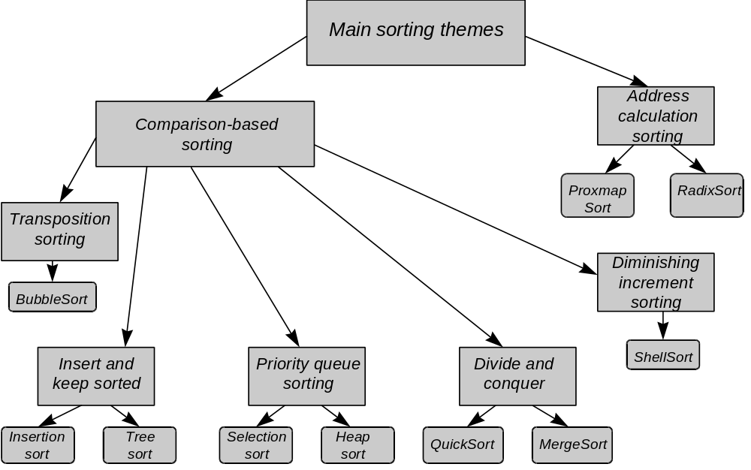

Comparison based sorting
- Transposition sorting:
- Bubble Sort is an example
- Simplest algorithms
- O(n²) but of all the O(n²) algorithms has the slowest actual performance due to number of swaps required as well as comparisons.
5
3
2
4

3
5
2
4

3
2
5
4

3
2
4
5

- Insert and keep sorted:
- Always inserts in the correct position
- Saw this with the Binary Search Tree which gives the Tree Sort. An in-order traversal visits each key in the tree in ascending order.
- O(n log n) because log n to find insertion place multiplied by the number of items to be inserted.
- Priority Queue sorting:
- Uses the Priority Queue ADT as part of the sorting algorithm
- We insert item keys into the queue in normal way but the front of the queue is always set to the largest item (highest priority == largest item).
- So largest in first out
- We’ll look at SelectionSort in some detail. This has time complexity of O(n²).
- Divide and Conquer sorting:
- Here we repeatedly divide n items into two partitions
- This reduces the number of comparisons required during sorting significantly.
- We either do a bit of sorting as we do the partitioning ending up with completely sorted array when no further partitioning can be done (QuickSort) or we do a bit of sorting at each level of merging of the partitions leading to completely sorted array when all the partitions have been fully merged (Merge Sort).
- Average case time complexity O(n log n), worst case O(n²)
QuickSort
Merge sort

- Diminishing increment sort:
- This is a more efficient version of the BubbleSort where comparisons and swaps are made between items that are initially further apart.
- Time complexity is O(n^{1.25})

SelectionSort Algorithm
It’s only O(n²) but its advantage over O(n log n) sorts is its simplicity. Also, for very small sets of data you may actually find it more efficient than O(n log n) algorithms. This is because many of these more complex sorts have a relatively high level of overhead associated with them, e.g. recursion is expensive compared with simple loop iteration. This overhead might outweigh the gains provided by a more complex algorithm where small number of data items are being sorted.

SelectionSort does better than BubbleSort as fewer swaps are required, although the same number of comparison operations are performed.
SelectionSort uses the Priority Queue ADT so start by looking at that.

Normal queues have FIFO semantics, add to back, remove from front.

PQ is largest-in-first-out, where largest is highest priority. Item with largest queue is at front of the queue:

5
3
10
7
12
6
1
9

front
PQLast

So if object containing this array (supporting PQ) receives message removeFromFront() then the object containg 12 is returned.

Space left is filled by the item indexed by PQLast and PQLast is decremented by one.

The message addToBack would place new item in the space after PQLast and PQLast would be incremented by one.

Major disadvantage of PQ is performance overhead of finding the next largest item. We have to traverse over the entire PQ to find it.

What has this got to do with sorting?

Each item extracted will be smaller or equal in size to the last item extracted. Items received in descending sort order.

4
2
6
1

6
2
4
1

If we wanted it to be sorted in ascending order then we could insert from the back of the destination array, skipping over any blank (null) elements first. However, we still need to use two arrays instead of one to do the sorting.

The SelectionSort uses just one array leaving the array sorted in ascending order.

Conceptually there are two subarrays within this array:
- One for the PQ of unsorted items
- Another for the sorted items

6
9
4
3
5
4
7
Priority queue
a

PQLast
front

General algorithm:
- Initialise PQLast
- Search from a’first to PQLast for largest item key: i.e. front
- Swap item indexed by front with item indexed by PQLast
- Decrement PQLast by one
- Repear steps 2 - 4.
Priority queue
Sorted subarray

6
7
4
3
5
4
9
a

PQLast
front

The pseudocode for the SelectionSort is:

void selectionSort(ComparableItem[] a)
{
// The end of the priority queue is initially the end // of the array. We assume the whole
// array is being sorted
//
PQlast = sizeOf(a) - 1;
//
// Extract each item from the PQ (largest out
// each time) and insert
// into front of the sorted part of the array "a"
// (PQlast is used to identify this)
//
while (PQlast > array start position)
{
front = 0;
// Search for the largest item in the PQ subarray
//
for (each element of PriorityQueue subarray)
{
if (a[currentElement] > a[front])
{
front = currentElement;
}
}
// Swap largest found with a[PQlast]
exchange a[front] with a[PQlast];
decrement PQlast by 1;
}
}

The SelectionSort has a time complexity of O(n²).
The two main sort operations being performed in the algorithm are:

- Swapping items between PQ subarray and the sorted subarray. n - 1 exchanges are performed so time complexity for this operation is O(n).
- Comparisons to find the largest item in the PQ subarray (to find front index). So there are (n-1) + (n-2) + … + 2 + 1 comparisons, which can be written as (n (n-1)) / 2. This is classified as O(n²).

The dominant operation (time-wise) is used to give the overall time complexity. So overall complexity is O(n²).

The actual performance is much better than this. However, the growth curve of the SelectionSort has similar characteristics to that of O(n²) growth curve. As you double the input data set (i.e. n) the number of operations for both growth curves increases fourfold. This is not the case with other curves, such as the O(n log n) curve. Hence, the most appropriate time complexity classification for SelectionSort in O(n²).

Divide and Conquer sorts
For the MergeSort an initial array is repeatedly divided into halves (usually each is a separate array) until arrays of just one element remain. A little bit of sorting is then done at each level of recombination:

Merging as recombining arrays

1
2
4
5

i3

1
5
2
4

i1
i2

5
1
4
2
10
2
9
15

- First merge smallest partitions’ values into the arrays with two elements. The smallest value of each pair gets propagated up before the larger value.
- General algorithm: three indices: i1, i2 and i3 as shown above.
- Compare i1 value with i2. Smallest value is propagated up to i3 at the next level up. If i1’s value is propagated up then i1 is increment by one, else i2 is increment by one. The diagram above shows the positions of the indices after all the values have been propagated up to the next level.

It’s left as an exercise to complete the overall sorting.

MergeSort doesn’t tend to get used too much for serious sorting, as tends to use lots of temporary space to hold intermediate results before merging array values.

QuickSort is more efficient in term of space since it partitions within a single array.

Both run to an average time complexity O(n log n). However, the QuickSort can, under certain rare conditions, perform much worse and run to O(n²).

The following is the top-level algorithm for the QuickSort.

1 void quickSort(ComparableItem[] a, int first, int last)
2 {
3 // Sort the subarray a[first:last]
4 //
5 if (there is more than one item to sort in
a[first:last])
6 {
7 pivotPosition = partition(a[first:last] into a
left partition and a right
partition using one of the
items in "a" as a pivot and
ensuring that left partition
items < pivot item value and
right partition items >= pivot
item value);
8 quickSort the left partition(a, first,
pivotPosition - 1);
9 quickSort the right partition(a,
pivotPosition + 1,
last);
}
}

The left partition is the subarray to the left of the pivot element and the right partition is the subarray to the right of the pivot item. Partition returns the index of the pivot item. The pivot will be in its correctly sorted position within the array, however the left and right partitions require further sorting. This is done by recursively calling quickSort on first the left partition and then the right partition. Note that the pivot item, because it is in its correct position in the overall array, is not part of the left or right partitions, it does not require further sorting.

The following is a revision exercise to help you understand the top-level algorithm. Will come back to details of the partition method later.

Use the above pseudocode algorithm for the QuickSort to sort the following array:

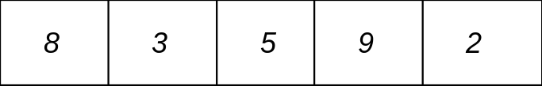

Represent each step of the sorting using stack diagrams. The following illustrates the first two steps. Your task is to continue with the subsequent steps. Assume the partition finds the pivotPosition with the formula (first+last)/2 and truncates to a whole integer value. The left partition is the subarray to the left of this pivot index and the right partition is the subarray to the right of the pivot index. OCCASIONALLY THE LEFT OR RIGHT PARTITION MAY BE EMPTY, I.E. THERE MIGHT ONLY BE A RIGHT OR A LEFT PARTITION BUT NOT BOTH. Push onto the stack when doing a recursive call and pop every time the method returns. Although you don’t have to understand the details of the partition method here, make sure that the two invariants spelt out in the pseudocode are not broken.

Step description | Current executing frame | Stack frames
Step 1: First call to quickSort | first = 0  last = 4  pivotPosition = 2
Step 2: Recursively call quickSort(a, 0, 2-1)  first = 0  last = 4  pivotPosition = 2  currentLine = 8  push | first = 0  last = 1  ….

Remember that whenever the method returns then you need to pop the stack to restore the previous frame so that it becomes the current executing frame again. This includes the local variables (such as last and first and pivotPosition) and the current line of execution.

Lets now look at the algorithm for doing partitioning. Its two main tasks are
- Choosing a pivot
- Shunting items to the left and right of the pivot in order to maintain the invariants mentioned earlier.

private int partition(ComparableItem[] a,
int first,
int last)
{
pivotPos = middle item of "a"; // Other more
// sophisticated ways
// of finding pivot
// can also be used

// Place the pivot item out of the way
//
swap a[pivotPos] with a[first];
pivotPos = first;
swapPos = first + 1;
//
// Loop through "a" moving larger items towards the
// end of the array and smaller items towards the
// front
//
for (each element in "a" between first+1 to last)
{
// If the current element is smaller than pivot we
// move it towards start of array
//
if (a[currentElement] < a[pivotPos])
{
swap a[swapPos] with a[currentElement];
increment swapPos by 1;
}
}
// Now move the pivotItem back to its rightful place
// in the array
//
swap a[pivotPos] with a[swapPos-1];
return swapPos-1; // PivotItem position
}

Time complexity of QuickSort

Average paerformance O(n log n):

7 comparisons

3+2 comparisons

Termination condition in quickSort main algorithm prevents further attempts at partitioning

1 comparison

13 comparisons
6 swaps (assuming half all comparisons on average result in a swap)

19 operations overall

From O(n log n) you would expect about 24 operations. OK we’ve done better than that but for larger numbers of data items the difference becomes less significant.

Worst case time complexity of O(n²) can be achieved if the data is arranged such that every time the pivot item is selected for a partition it is always the largest item in that partition:
Comparisons

7

6

5

4

3

2

1

28 total
28 Swaps also required

56 operations overall

There are 28 swaps because the statement

if (a[currentElement] < a[pivotPos])

will always be true if the pivot item is the largest item in the partition. For O(n²) we would expect 64 operations. However, 56 is sufficiently close to enable us to classify this worst case behaviour as O(n²). The are better algorithms for selecting the pivot which makes this worst case behaviour even less likely, e.g. selecting three pivots and choosing the pivot with the intermediate value.

Worked exam question

Question 4 (adapted) from CS21020 paper 1996-97

- Show that the algorithm to sort n numbers:

for (int I = a.length - 2; I >= 0; I--)
{
for (int j = 0; j <= I; j++)
{
order(a[j], a[j+1]);
}
}

has a time complexity of O(n2). The method order(x, y) swaps x and y when x > y.
[4 marks]

One way to answer this is to use an example array to illustrate how the algorithm operates:
a
8
7
6
5
4

i
j

and then step through the algorithm showing that the number of comparisons required is 4 for the first iteration, 3 for the next etc to give 10 comparisons overall.

You would express this mathematically as (n-1) + (n-2) … + 2 + 1 or n*(n-1)/2

If the algorithm were O(n2) you would expect 25 operations. However, state that the classification is only an approximation that characterises the algorithm. It is the closest approximation, closer than O(n log n).

For an extra mark you might state that doubling the size of n results in a fourfold increase in the number of operations for both the n² growth curve and the n*(n-1)/2 growth curve, unlike the n log n curve.

b) Give pseudocode for an order O(n) algorithm for merging two sorted arrays of length n into a sorted array of length 2n. Justify the claimed complexity. [7 marks]

ComparableItem[] merge(ComparableItem[] a1,
ComparableItem a2)
{
// Assume that a1 and a2 are full of items
// Create the result array

result = new ComparableItem array of size a1.length +
a2.length;

// Initialise to indices used to index a1 and a2

a1Pos = 0;
a2Pos = 0;
for (each element of result)
{
// Check to see if all elements from a1 already
// transferred to result
if (a1Pos == a1.length)
{
result[currentElement] = a2[a2Pos];
increment a2Pos by 1;
}
// Check to see if all elements from a2
// transferred already
else if (a2Pos == a2.length)
{
result[currentElement] = a1[a1Pos];
increment a1Pos by 1;
}
// Move the smaller element of a1 or a2 to result
else if (a1[a1Pos] less than a2[a2Pos])
{
result[currentElement] = a1[a1Pos];
increment a1Pos by 1;
}
else
{
result[currentElement] = a2[a2Pos];
increment a2Pos by 1;
}
}
return result;
}

We are dealing with O(n) time complexity since the number of operations required depends linearly on the number of data items to be sorted. There are 2n data items to sort (n is therefore really 2n: the overall size of the data set to be merged) and for each we iterate around the for loop once so time is: (time to assign a value to result + time to increment the counter + time to increment the loop counter + time to execute the loop termination condition) * 2n. Doubling n will double the time to do the merging, it will double the data set to be merged and hence double the number of operations.

c) Consider a divide and conquer sorting strategy, in which algorithm (a) is used to sort two arrays, one after the other, each of length n, followed by a merge of the two arrays into an array of length 2n.
Show that, when n is sufficiently large, this algorithm leads to execution times typically 50% lower than for algorithm (a).
Moreover, if the divide and conquer strategy is repeatedly applied, show that an O(n log n) algorithm can be obtained. [9 marks]

The actual timing property of algorithm a is (n * (n-1))/2. So if we had an array with 128 elements the number of operations would by (128 * 127) / 2 which is 8128. If the array was split into two arrays where each was sorted separately using algorithm (a) followed by a merge then the number of operations required for each array would be (64 * 63)/2, which is 2016 which gives a total number of operations of 4032. We then add to this the number of operations required to do the merge which is 128 giving a total of 4160 operations. This is approximately 50% of the number of the 8128 operations for the case where the merging had not been done.

Where divide and conquer is repeatedly done (not just once as above) we get O(nlogn). We would expect from the formula 128 * 7 = 896 operations. If we repeatedly divide the 128 element array in halves we end up with 7 levels of division. In the lowest level there will be 128 subarrays each with just one element. If we apply the merge algorithm at each level then at each level there will be 128 operations. Given we have 7 levels that gives us 128 * 7 operations or 896 operations overall, the answer we were looking for. Notice that algorithm (a) is not used at all. You might like to draw a diagram of the array partitioned 7 times.

